**Fanka Shundovska**

**IntelliJ – JAVA Homework 1**

In IntelliJ:

1. Write code to output "Hello World".

package com.edu.sedc;  
  
public class JavaHomework1 {  
  
 public static void main(String[] args) {  
  
 String message = "Hello World";  
 System.*out*.println(message);

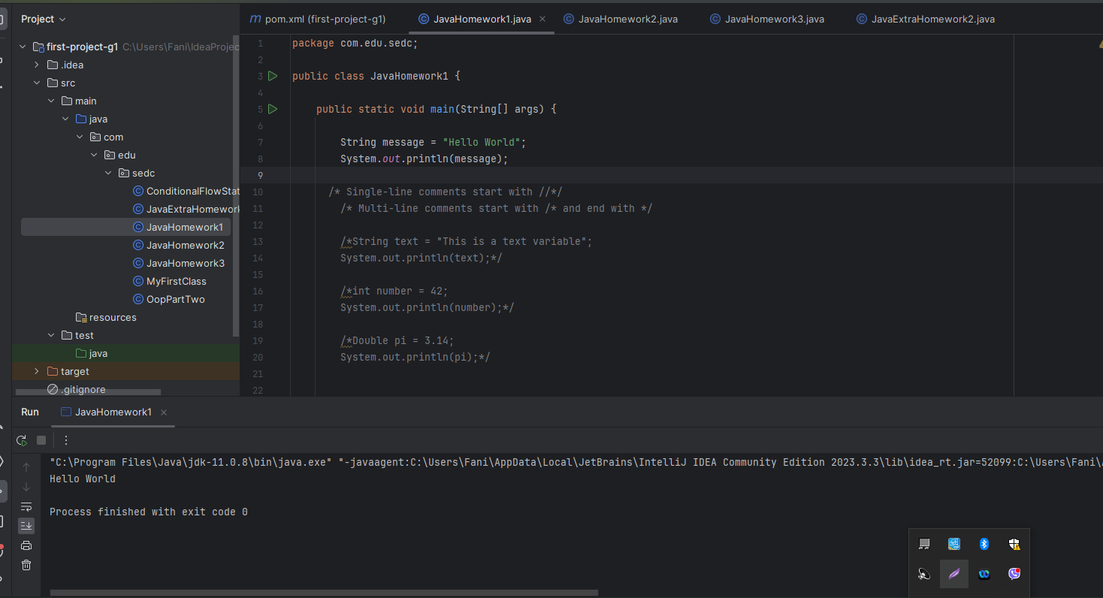

1. Insert the missing part:

* Single-line comments start with //
* Multi-line comments start with /* and end with */.

1. Inside the main() method insert a variable called text of type String and assign the value to it.

* Print the value of the result using System.out.println().

package com.edu.sedc;  
  
public class JavaHomework1 {  
  
 public static void main(String[] args) {  
  
   
 String text = "This is a text variable";  
 System.*out*.println(text);

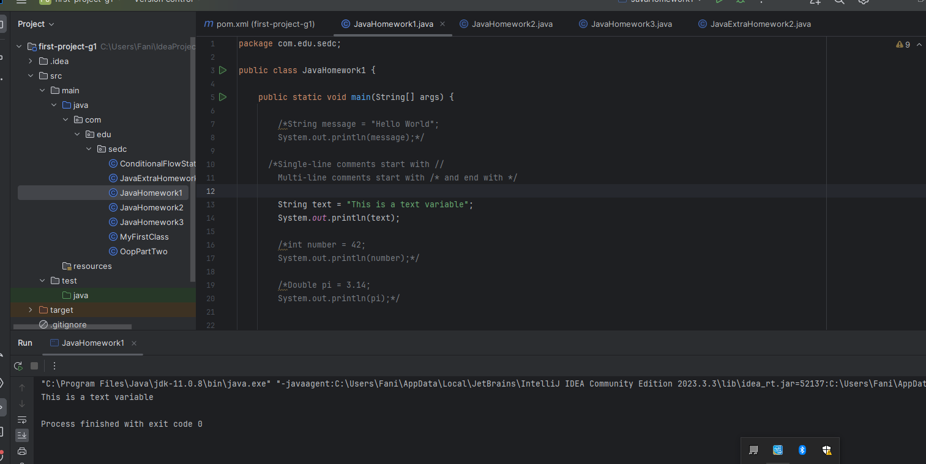

1. Create a variable of type int and assign the value to it.

package com.edu.sedc;  
  
public class JavaHomework1 {  
  
 public static void main(String[] args) {  
  
   
  
 int number = 42;  
 System.*out*.println(number);

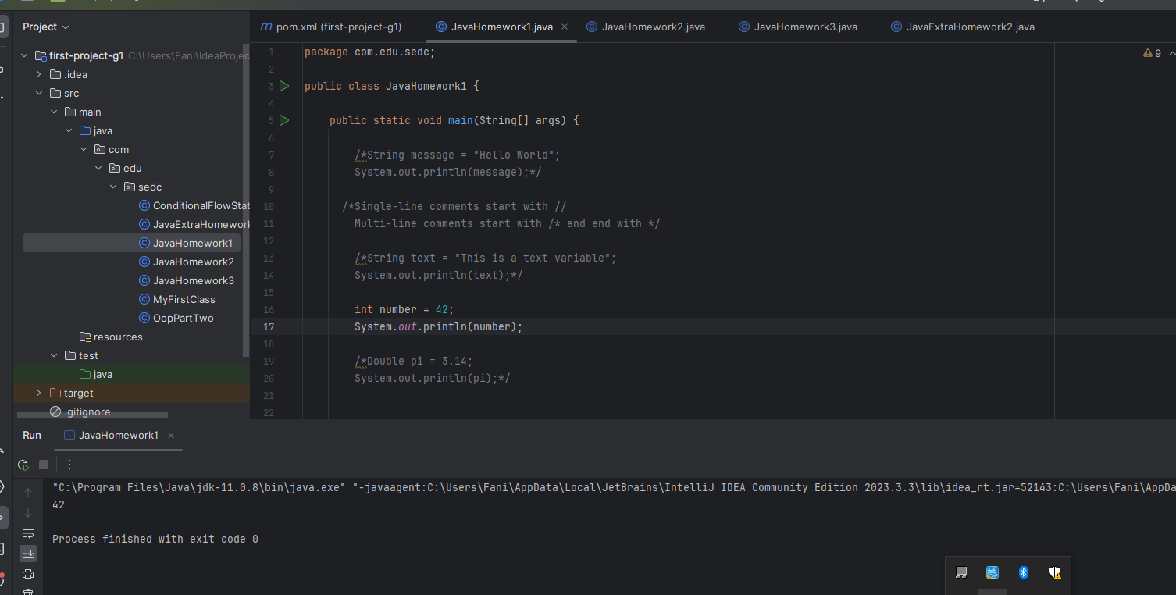

1. Create a variable of type double and assign the value to it.

package com.edu.sedc;  
  
public class JavaHomework1 {  
  
 public static void main(String[] args) {  
  
   
 double pi = 3.14;  
 System.*out*.println(pi);

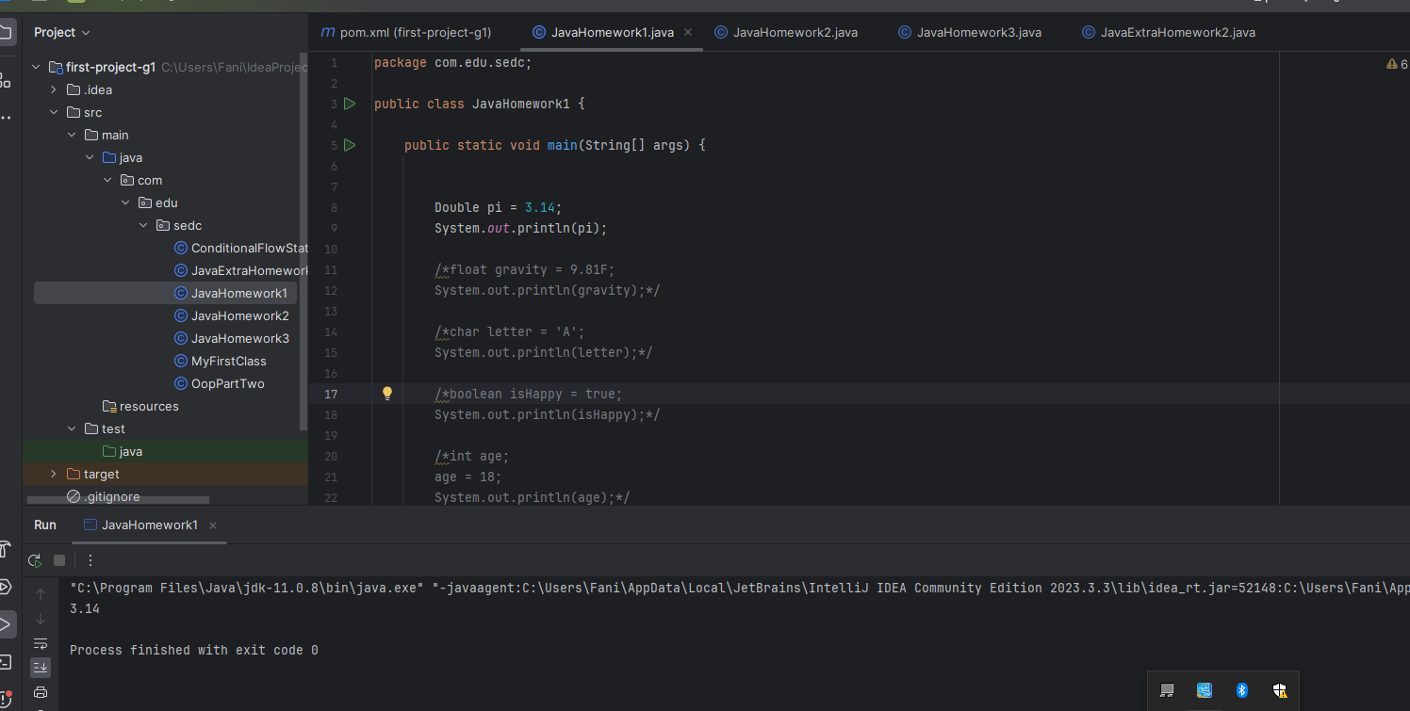

1. Create a variable of type float and assign the value to it.

System.out.println(pi);*/  
  
float gravity = 9.81F;  
System.*out*.println(gravity);

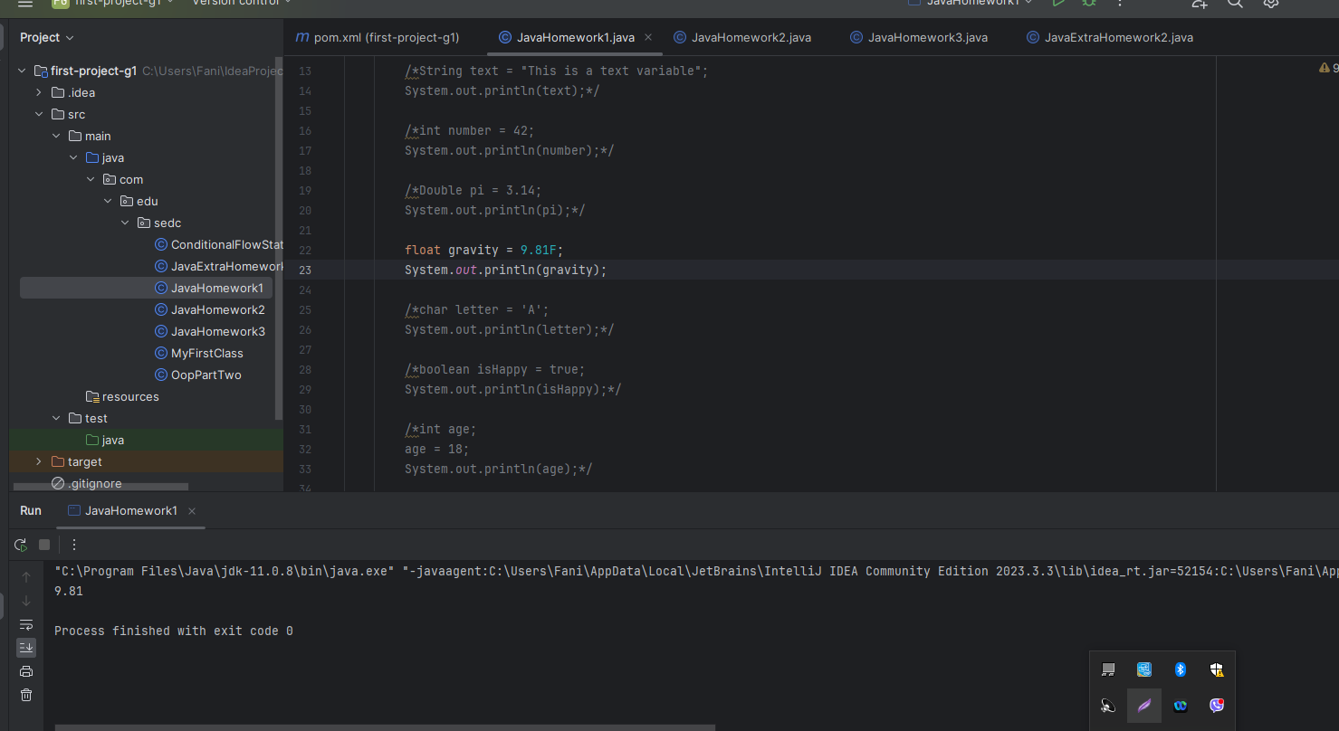

1. Create a variable of type char and assign the value to it.

char letter = 'A';  
System.*out*.println(letter);

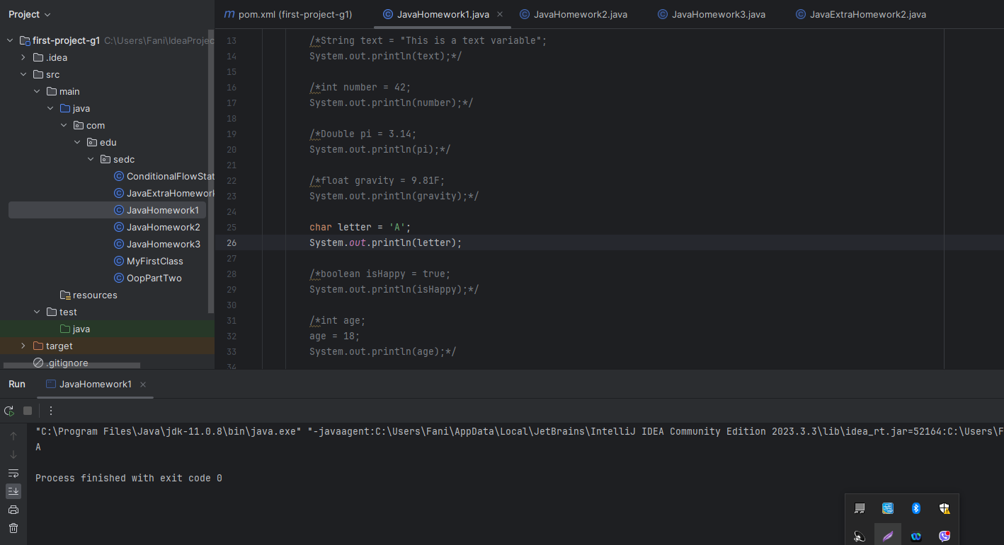

1. Create a variable of type boolean and assign the value to it.

boolean isHappy = true;  
System.*out*.println(isHappy);

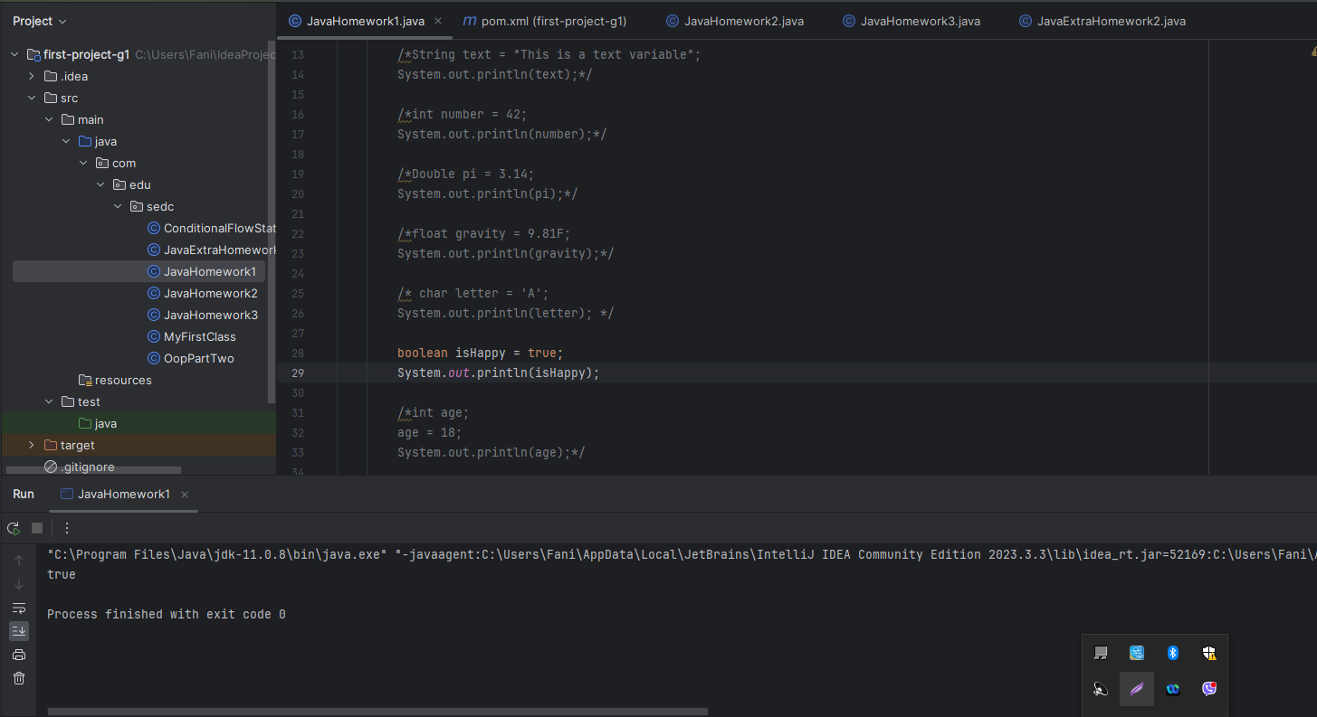

1. Declare a variable of type int without assigning the value.

* After declaring variable assign the value later.
* Print the variable value.

int age;  
age = 18;  
System.*out*.println(age);

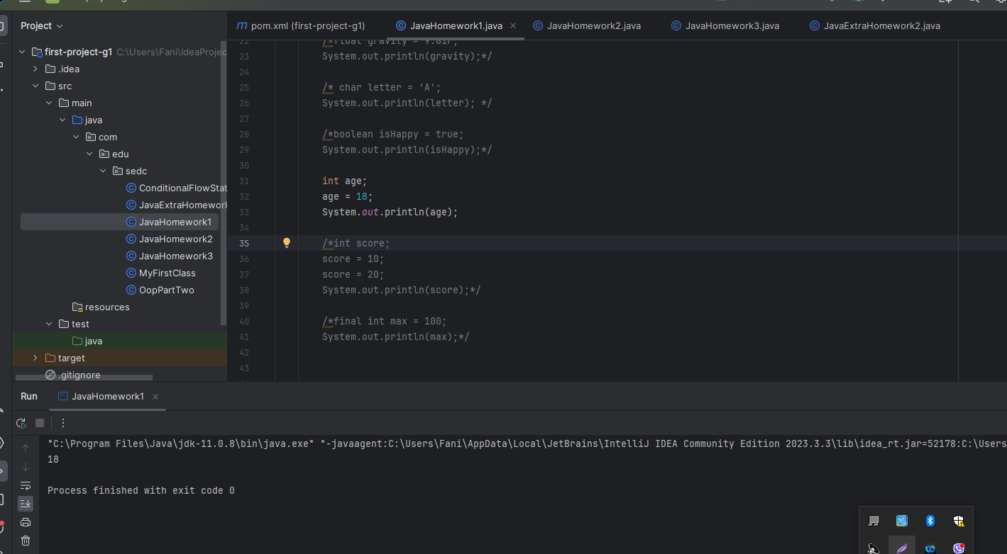

1. Declare a variable of type int without assigning the value, assign the value later.

* Assign a new value to an existing variable, to overwrite the previous value.
* Print the variable value.

int score;  
score = 10;  
score = 20;  
System.*out*.println(score);

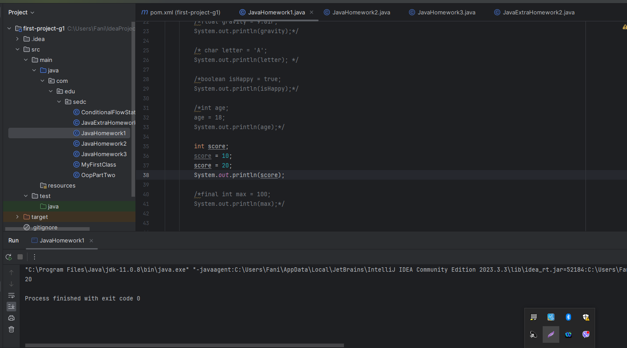

1. Create a variable of type int that others can not overwrite her existing value.

* Print the result.

final int max = 100;  
System.*out*.println(max);

